DAY-2
9. Double Transposition (User Input Version)
import math
# ---------- Helper Functions ----------
def get_order(key):
return sorted(range(len(key)), key=lambda i: (key[i], i))
def keyed_encrypt(text, key):
col = len(key)
rows = math.ceil(len(text) / col)
text += 'X' * (rows * col - len(text))
matrix = [text[i*col:(i+1)*col] for i in range(rows)]
order = get_order(key)
cipher = ""
for i in order:
for row in matrix:
cipher += row[i]
return cipher
def keyed_decrypt(cipher, key):
col = len(key)
rows = len(cipher) // col
order = get_order(key)
matrix = [''] * rows
idx = 0
for i in order:
for r in range(rows):
matrix[r] += cipher[idx]
idx += 1
result = [''] * rows
for r in range(rows):
temp = [''] * col
for pos, col_index in enumerate(order):
temp[col_index] = matrix[r][pos]
result[r] = ''.join(temp)
return ''.join(result).rstrip('X')
# ---------- Double Transposition ----------
def double_encrypt(text, key1, key2):
first = keyed_encrypt(text, key1)
return keyed_encrypt(first, key2)
def double_decrypt(cipher, key1, key2):
first = keyed_decrypt(cipher, key2)
return keyed_decrypt(first, key1)
# ---------- USER INPUT ----------
text = input("Enter Plaintext: ")
key1 = input("Enter First Key: ")
key2 = input("Enter Second Key: ")
cipher = double_encrypt(text, key1, key2)
print("Cipher:", cipher)
print("Decrypted:", double_decrypt(cipher, key1, key2))
OUTPUT:
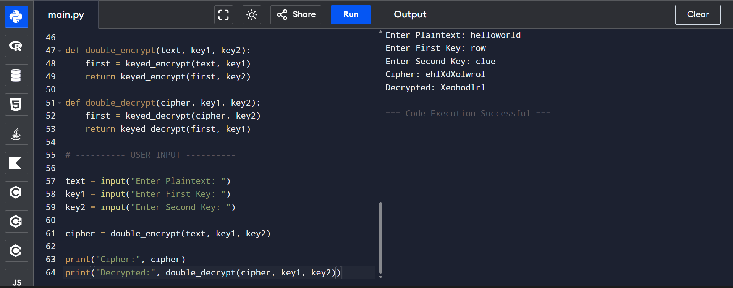

8. Keyed Columnar Transposition
import math
# ---------- Get Column Order ----------
def get_order(key):
return sorted(range(len(key)), key=lambda k: (key[k], k))
# ---------- Encryption ----------
def keyed_encrypt(text, key):
col = len(key)
rows = -(-len(text) // col) # Ceiling division
# Padding
text += 'X' * (rows * col - len(text))
# Create matrix
matrix = [list(text[i*col:(i+1)*col]) for i in range(rows)]
order = get_order(key)
print("\nKey Ranking:", order)
print("Original Matrix:")
for row in matrix:
print(row)
cipher = ''
for i in order:
for row in matrix:
cipher += row[i]
return cipher
# ---------- Decryption ----------
def keyed_decrypt(cipher, key):
col = len(key)
rows = len(cipher) // col
order = get_order(key)
matrix = [[''] * col for _ in range(rows)]
index = 0
# Fill column-wise according to sorted order
for i in order:
for r in range(rows):
matrix[r][i] = cipher[index]
index += 1
print("\nReconstructed Matrix:")
for row in matrix:
print(row)
result = ''
for row in matrix:
result += ''.join(row)
return result.rstrip('X')
# USER INPUT SECTION
text = input("Enter Plaintext: ")
key = input("Enter Keyword: ")
cipher = keyed_encrypt(text, key)
print("\nCiphertext:", cipher)
decrypted = keyed_decrypt(cipher, key)
print("Decrypted Text:", decrypted)
OUTPUT:
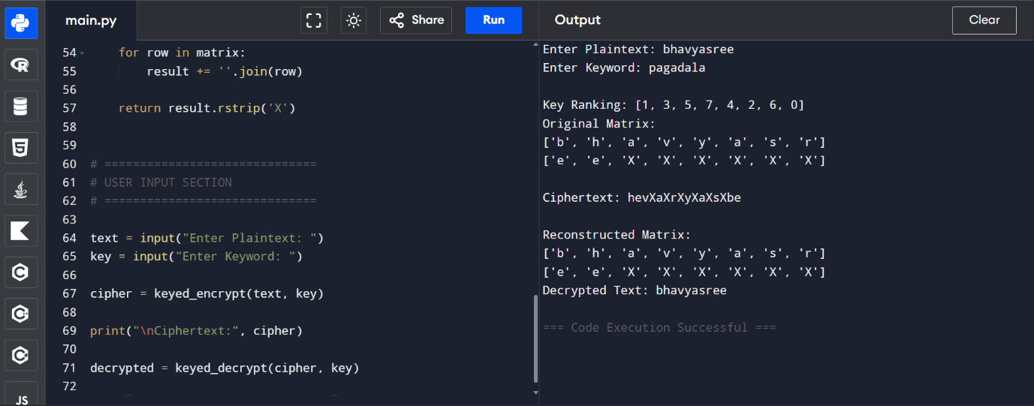
10. CRYPTANALYSIS TOOL
import math
import itertools
from collections import Counter
# -------- Columnar Encryption --------
def columnar_encrypt(text, key, pad='X'):
rows = math.ceil(len(text) / key)
text += pad * (rows * key - len(text))
matrix = [text[i*key:(i+1)*key] for i in range(rows)]
cipher = ""
for col in range(key):
for row in matrix:
cipher += row[col]
return cipher
# -------- English Frequency Scoring --------
freq = {'E':12, 'T':9, 'A':8, 'O':7}
def score(text):
c = Counter(text.upper())
return sum(c.get(ch,0) * freq.get(ch,0) for ch in freq
# -------- Brute Force Attack --------
def brute_force(cipher):
results = []
for k in range(2,6): # small range to avoid heavy computation
if len(cipher) % k != 0:
continue
rows = len(cipher) // k
for perm in itertools.permutations(range(k)):
matrix = [''] * rows
idx = 0
for col in perm:
for r in range(rows):
matrix[r] += cipher[idx]
idx += 1
text = ''.join(matrix)
results.append((score(text), text))
results.sort(reverse=True)
return results[:5]
# ==============================
# USER INPUT SECTION
# ==============================
plaintext = input("Enter Plaintext: ")
key = int(input("Enter Key Length (for encryption): "))

cipher = columnar_encrypt(plaintext, key)

print("\nGenerated Ciphertext:", cipher)

print("\nTop 5 Possible Plaintexts (Brute Force Attack):")
for s, t in brute_force(cipher):
print("Score:", s, "| Text:", t)
OUTPUT:
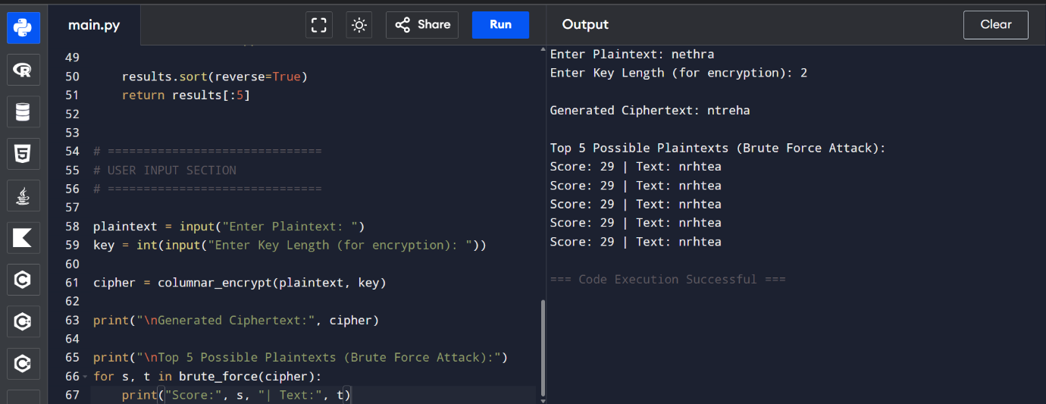
6.RAIL FENCE CIPHER
# Rail Fence Cipher (User Input Version)

def rail_fence_encrypt(text, r):
if r <= 1:
return text

rail = [[''] * len(text) for _ in range(r)]
row = 0
direction = 1

for col in range(len(text)):
rail[row][col] = text[col]

if row == 0:
direction = 1
elif row == r - 1:
direction = -1

row += direction

cipher = ""
for i in range(r):
for j in range(len(text)):
if rail[i][j] != "":
cipher += rail[i][j]

return cipher

def rail_fence_decrypt(cipher, r):
if r <= 1:
return cipher

rail = [[''] * len(cipher) for _ in range(r)]
row = 0
direction = 1

# Mark zigzag
for col in range(len(cipher)):
rail[row][col] = "*"

if row == 0:
direction = 1
elif row == r - 1:
direction = -1

row += direction

# Fill characters
index = 0
for i in range(r):
for j in range(len(cipher)):
if rail[i][j] == "*" and index < len(cipher):
rail[i][j] = cipher[index]
index += 1

# Read zigzag
result = ""
row = 0
direction = 1

for col in range(len(cipher)):
result += rail[row][col]

if row == 0:
direction = 1
elif row == r - 1:
direction = -1

row += direction

return result

# =========================
# USER INPUT SECTION
# =========================

text = input("Enter Plaintext: ")
rails = int(input("Enter Number of Rails: "))
cipher = rail_fence_encrypt(text, rails)
print("Cipher:", cipher)
print("Decrypted:", rail_fence_decrypt(cipher, rails))
OUTPUT:
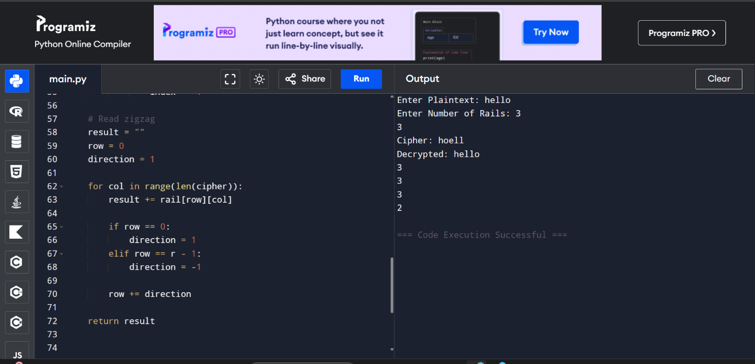

7.SIMPLE COLUMNAR TRANSPOSITION
import math

# Encryption
def columnar_encrypt(text, key, pad='X'):
rows = math.ceil(len(text) / key)
text += pad * (rows * key - len(text))

matrix = [text[i*key:(i+1)*key] for i in range(rows)]

cipher = ""
for col in range(key):
for row in matrix:
cipher += row[col]

return cipher

# Decryption
def columnar_decrypt(cipher, key, pad='X'):
rows = len(cipher) // key
matrix = [''] * rows

index = 0
for col in range(key):
for row in range(rows):
matrix[row] += cipher[index]
index += 1

return ''.join(matrix).rstrip(pad)

# ==========================
# USER INPUT SECTION
# ==========================

text = input("Enter Plaintext: ")
key = int(input("Enter Key Length: "))

cipher = columnar_encrypt(text, key)

print("Cipher:", cipher)
print("Decrypted:", columnar_decrypt(cipher, key))
OUTPUT:
